Series TM Type Makers' Tools
Device 15TM Signature Jig

Signature Jig
Manual and Parts List

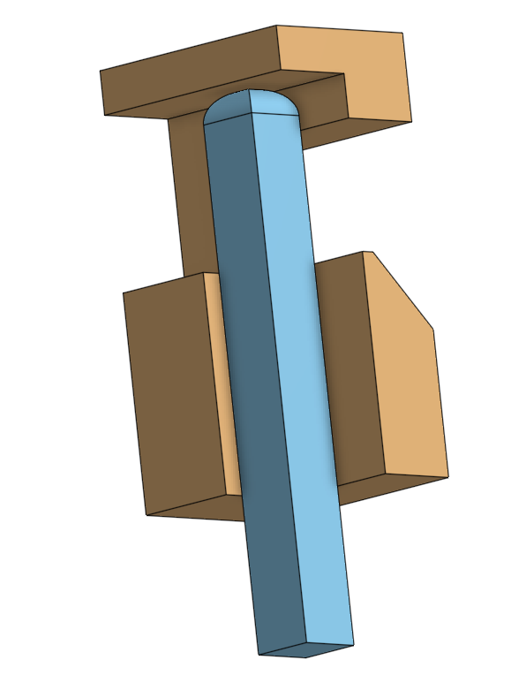
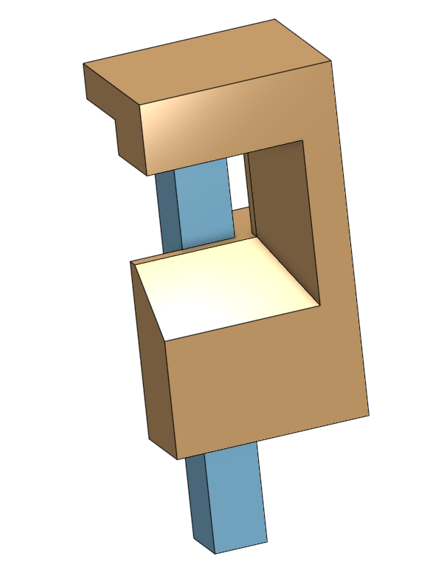

Open Source Hardware by
CircuitousRoot

Manufactured by
[your name here]
What This Device Is
In cutting a punch or patrix, by hand or machine, it is necessary to mark one side of the punch/patrix so as to allow its orientation to be distinguished. Most simply, this can be done by scribing a line across one of the four sides. This line is called the signature mark. Stan Nelson notes that French punchcutters put this line on the back side of the punch (just as French type has its nick at the back). His own practice (and I assume also general Anglo-American practice) puts the signature mark on the front side of the punch. Stan puts his signature mark about 1/3 of the way up from the hammer-end of the punch.
If the punchcutter also has a personal engraver's mark - that is, a punch with their own distinctive mark - the punch may also be stamped with it in addition to the line of the regular signature mark. {Nelson 2016}
It looks better if all of the signature marks line up across the series of punches. An easy way to ensure this is to use a signature jig. This is nothing more than a small piece of brass or other material relieved to accommodate the hammer-end of a punch and provided with an opening through which the signature mark may be scribed at a fixed distance from the hammer-end.
Typically the signature mark is scribed first; this leaves a relatively light line. Then the signature jig is removed and the line is deepened using needle files.
To people such as myself who spend too much time thinking about these things, a question naturally arises at this point: is this device a "jig" or a "fixture"?
These two terms are sometimes used interchangeable or inconsistently. Carr Lane Mfg. Co., a major and long-established supplier of tooling and components for jig and fixture manufacturing, has established the following convention:

"A jig ... guides the cutting tool. A fixture references the cutting tool." ( {Carr-Lane 1995}: 2)
Using this definition, the present device is jig, not a fixture.

Evidence
I am unware of any published example of or reference to this jig as of 2017.
We know that it must be used at l'Imprimerie Nationale in France because Stan Nelson writes of it and draws it in his Paris '92 Sketchbook, ( {Nelson 2016}) However, I have not yet been able to find any photograph of one in the tools shown there.
Stan Nelson uses the signature jig shown below in his own work.
These are the only references of which I am presently aware. If I am missing any other reference due to my oversight or ignorance, I would appreciate learning of it.

Alternatives
A signature jig is not an essential tool of the punchcutter. The ordinary machinist's square can be used to scribe the signature mark, and a machinist's square should probably be on your punchcutting bench anyway. The signature jig just makes it easier.
The photo below left shows a machinist's square, punch blank, and scribe. The photo below right shows a signature mark on a (not very good) punch blank after it has been deepened by filing. In both photos, the hammer end is the rounded end of the punch.
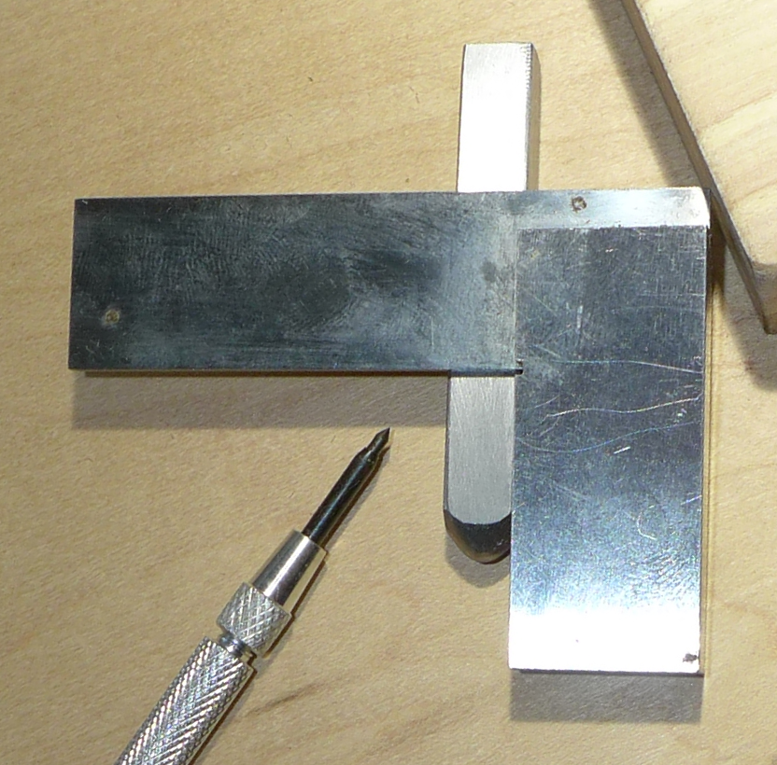
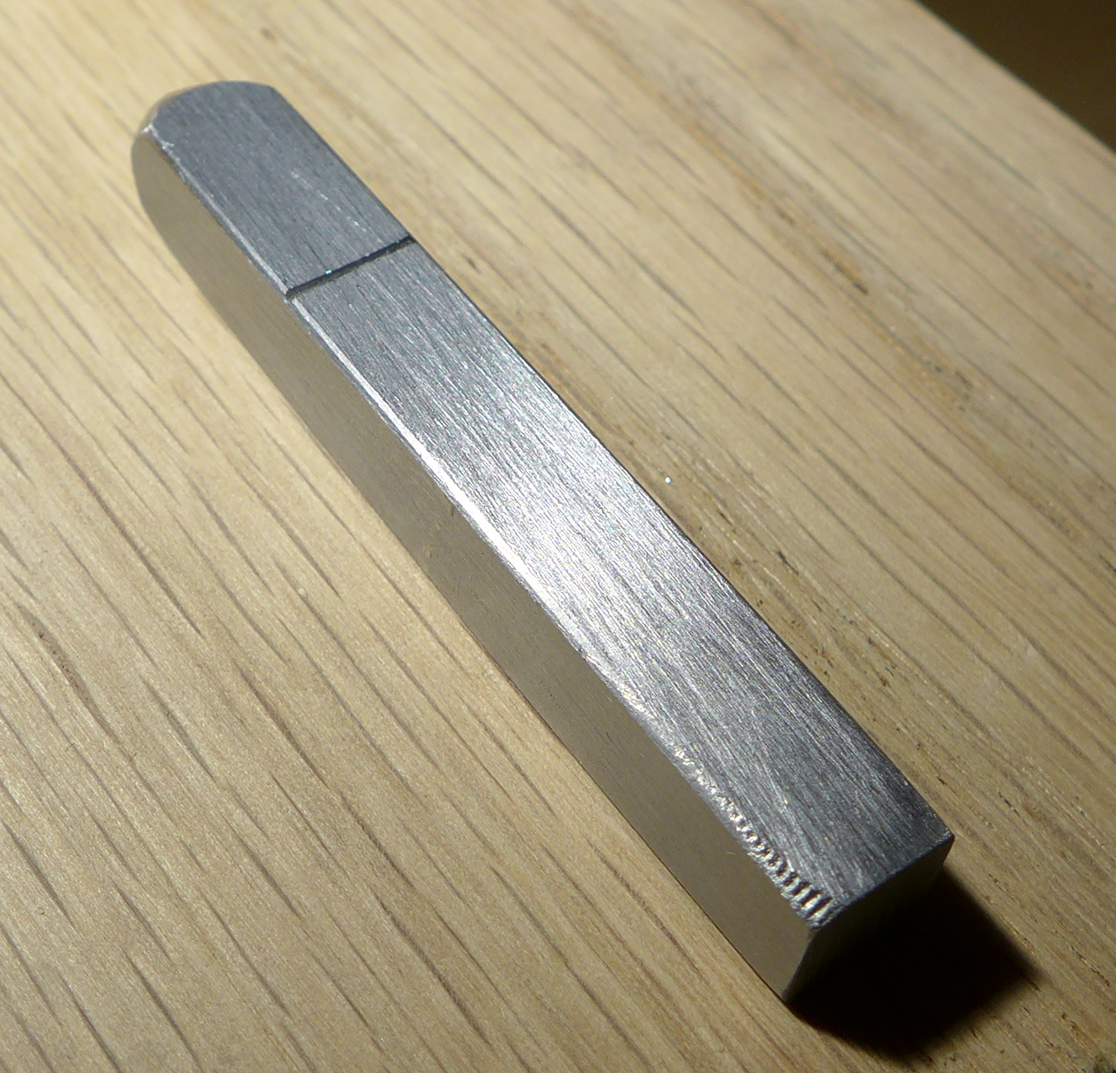
Stan Nelson's Signature Jig
This is the signature jig made by Stan Nelson. I had the opportunity to photograph it during his 2016 Wells College punchcutting class. My thanks to Stan both for the class and for his generosity in allowing us to photograph his extensive set of tools (many of which he made himself).
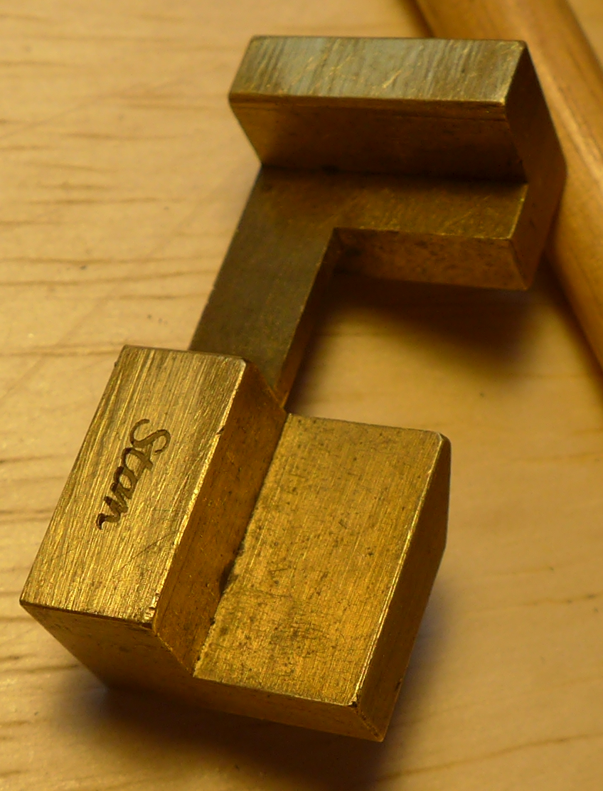
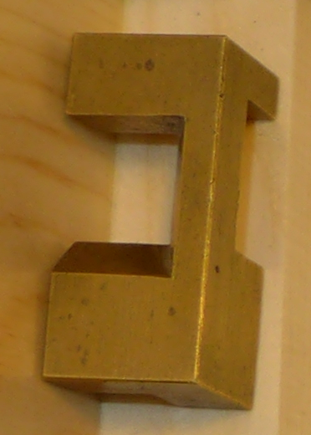
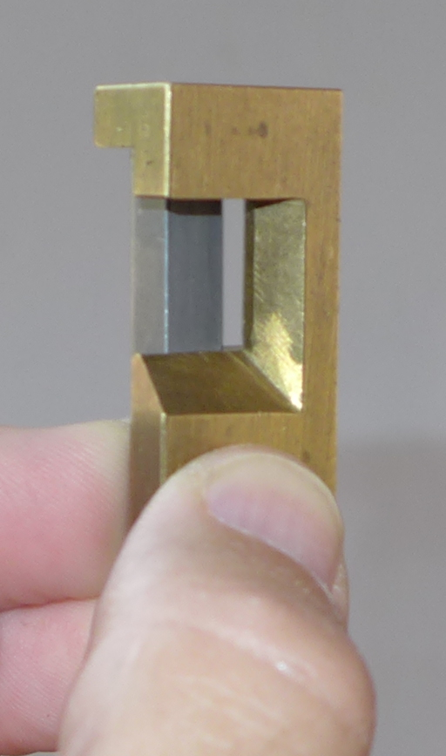

The third view above shows a punch blank in place. Although it is not visible, the finished hammer-end of the punch blank is to the top, held against the top "shelf" of the signature jig. You would scribe the line of the signature mark along the horizontal bevel at the bottom of the cutout/window.

Here it is in the conventional six orthographic views as you would see it in a third-angle projection:.
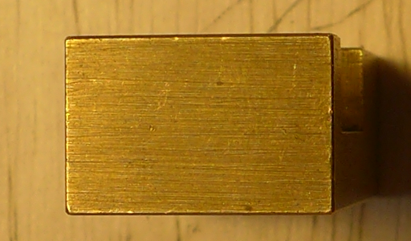

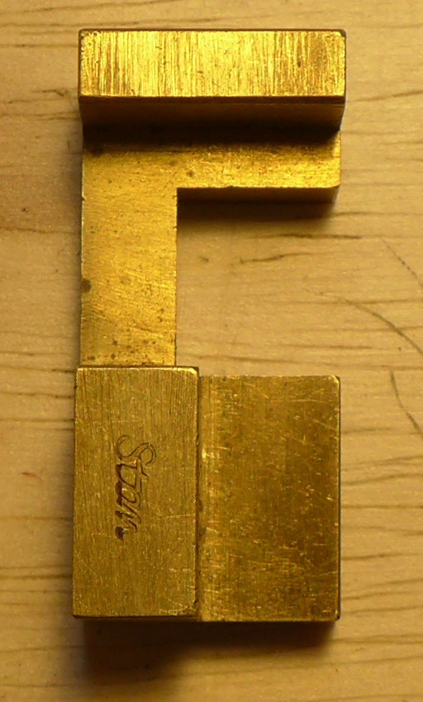
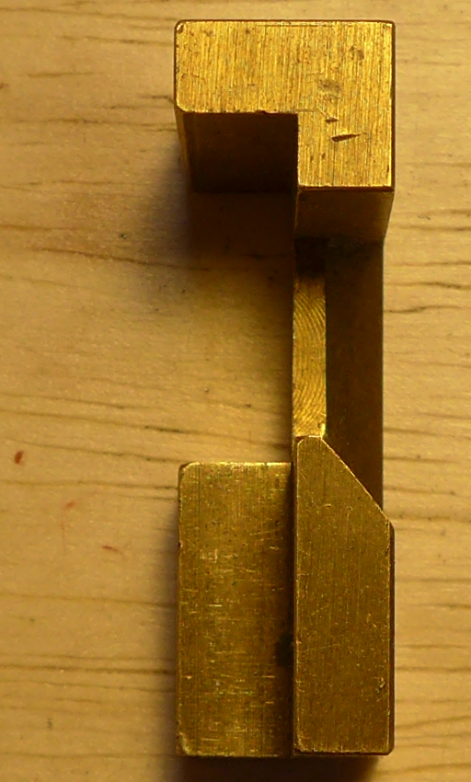
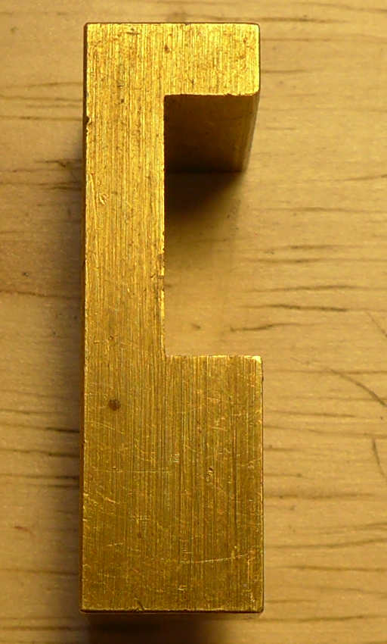
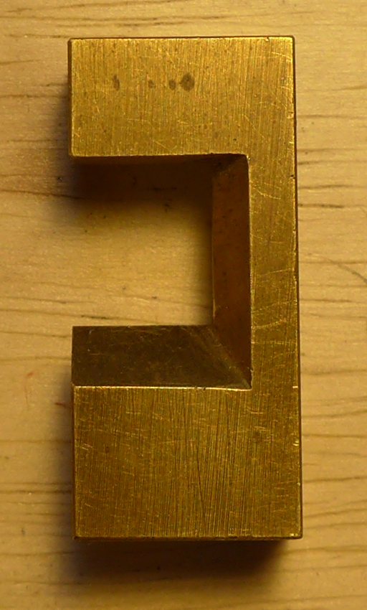
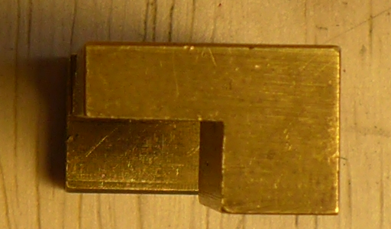

About The 15TM Signature Jig
This is a signature jig based on Stan Nelson's. It is designed to accommodate flat-sided punches of approximately 2 1/4 inches length at up to 36 American points in punch blank width. It would not work well with the less flat sides of earlier punches as shown in Moxon. (Moxon's hand-forged punches are more cigar-shaped in their longitudinal profiles, and might rock if used in this gauge.) It may be used for both punches in steel or patrices in soft metal, but it is not appropriate for significantly shorter machine-cut punches or patrices. However, its dimensions may be varied at will to suit the punch or patrix being made.
As this is a type making tool, it is dimensioned appropriately in points. (I'm using American Printers' Points, taken to be 0.013,8 inches, but any point system would work just as well.) It positions the signature mark 48 points from the hammer end. This is a bit less than 1/3 of the length of a 2 1/4 inch (163 point) punch - you may wish to alter this position.
How to Use this Device
Here are two CAD-generated views of this jig, shown with an example punch blank in place. The punch blank is placed with its finished hammer end up. (You want to finish the hammer end of the punch before scribing the signature mark.)
To use this jig, place the punch blank in it as shown and use a scribe to scribe the signature mark across the width of the punch blank at the jig's bevel. Then remove the punch blank and deepen the signature mark with the needle file of your choice.
Parts List
Note: A symbol without a numeric suffix (e.g., “15TM”) indicates a logical group of parts. It does not designate any specific physical item.
Note: The prefix ‘X’ indicates an ordering code for the entire preceding part back up the list to the logical group identification. Thus, “X15TM” is the ordering code for the entire logical group 15TM.

0ZZ General Documentation
0ZZ1 Binder
0ZZ2 Binder Slipcase
0ZZ3 Licensing Terms

0TM/OTF Series TF & TM General Documentation
0TF3/0TM3 Series TF & TM Cover Page and Binder Labels
0TM4 Series TM Device List
0TM4 Series TM Introduction

15TM Signature Jig
15TM0 Signature Jig Manual and Parts List (what you're reading now)
15TM1 Signature Jig
Note: I haven't yet designed the box (much less built it), but I'm allocating part symbols for it nonetheless.
15TM2 Box, Metal Bottom
15TM3 Box, Metal Top
15TM4 Box, Wooden Insert, Bottom
15TM5 Box, Wooden Insert, Top
15TM6 Box, Felts (set)

X15TM Signature Gauge, Complete

Implementation
CAD/Modeling
I modeled this in 3D using the Onshape® "cloud-based" CAD system, and generated a 2D engineering drawing from that model. It's all very simple.
The model and drawing are dimensioned in printers' points (at least as far as I can emulate these in Onshape: in the model I defined a point as a variable and used equations; in the drawing I had to override each dimension explictly).
Drawing
A PDF-format printable engineering drawing of this device,

  - Drawing No. 15TM1-D1

is distributed with this project on its main page (see "Distribution," below). Modified versions as needed may be derived trivially from this drawing or its underlying CAD model.
Distribution
The main page for this device on CircuitousRoot is:
http://www.CircuitousRoot.com/artifice/letters/press/typemaking/making-matrices/tools-of-the-hand-punchcutter-in-steel/signature-jig/index.html

The distribution there includes digital copies of the engineering drawing(s), exported versions of the CAD models, manufacturing operations schedules, this present manual, and other documentation.
The original CAD models for the parts of this device are online in the "cloud-based" Onshape CAD service. If you have a free or fee-based Onshape account, you may view and copy the Onshape “Document” (their word for “Project”) at:
https://cad.onshape.com/documents/005fc0e1711a6edf2ca3f898/w/c9a3c4bc0021ea25798e9dda/e/e1ad52edc0165cb6e50c829f

Design and Licensing
The punchcutters' signature jig is a traditional device which predates all modern concepts of intellectual property; its design is in the public domain.
My thanks to Stan Nelson for graciously sharing his information about this tool.
This particular implementation of a signature jig is Open Source Hardware. Its CAD model, engineering drawing(s), and other documentation are kept open and protected from from proprietization by “copyleft” licensing terms.
If you received this documentation from, or redistributed from, CircuitousRoot, please see the “Notebook on Open-Source Hardware on CircuitousRoot” for further information:
http://www.CircuitousRoot.com/oshw.html

In particular, please see the CircuitousRoot Open Source Hardware document 1ZZ0, "Licensing Terms," for more information.
If you received this device as manufactured by The Singing Lemur LLC, please see Singing Lemur product manual Section 1ZZ0, “Licensing Terms” for more information. A printed version of this section may have accompanied this product; if not, see:
http://www.lemur.com/oshw.html

Construction
A partial account of the making of this jig in my small home machine shop is online on the main distribution page for this project.
If you make this jig (or one derived from it, or one of your own design), I would very much like to learn of it.
Snapshot of the Drawing
The next page contains a copy of the drawing for this part. Please check the online distribution before using this drawing, as it may be out of date.
Also note that the drawing as reproduced here, within the margins of this page, is smaller than the same drawing as printed from its source file directly.

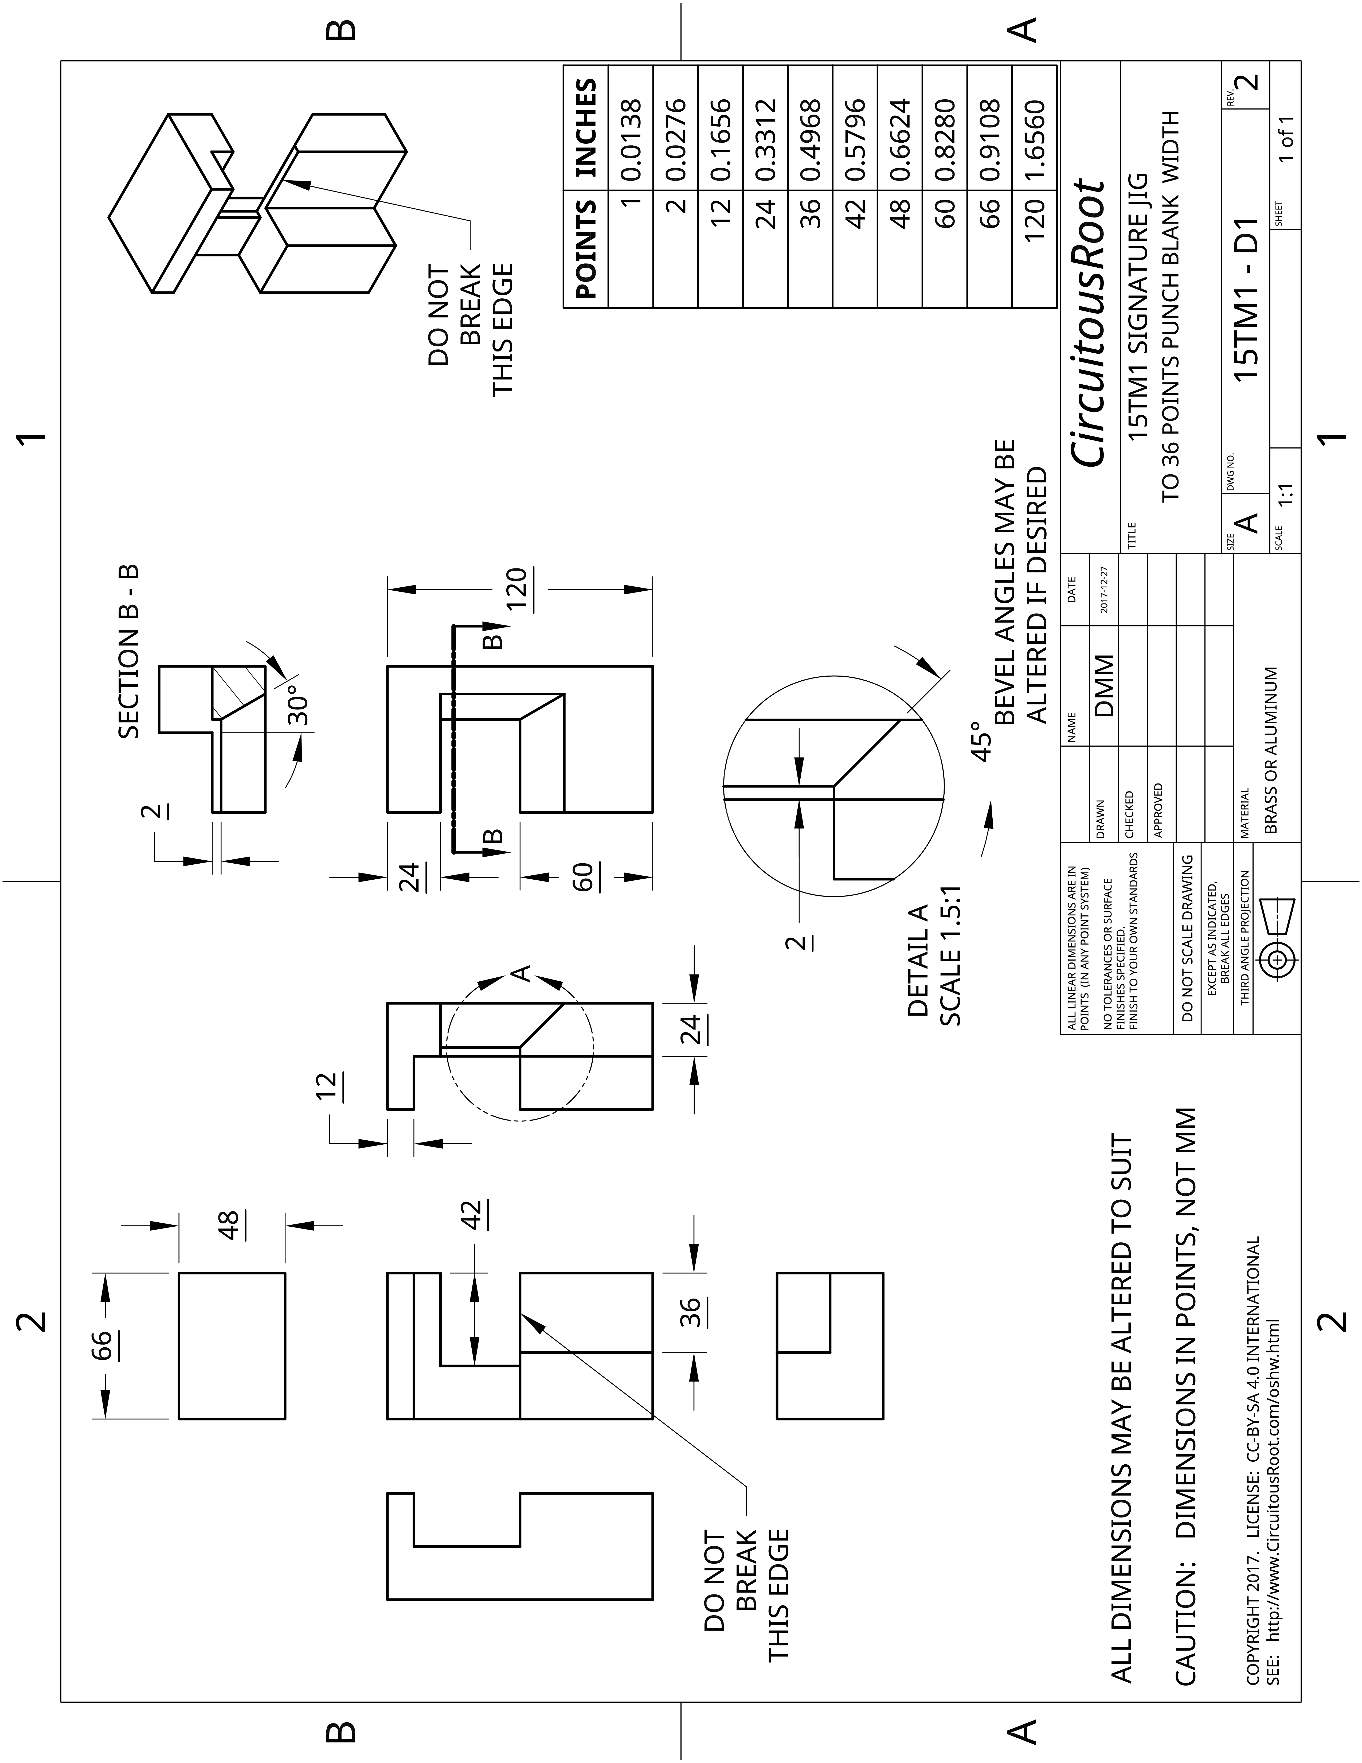

References
{Carr-Lane 1995} Carr-Lane Mfg. Co. Jig and Fixture Handbook. Third Edition. St. Louis, Mo: Carr-Lane Mfg. Co., 1995
{Nelson 2016} Nelson, Stan. Paris '92 Sketchbook. Charles Town, WV: [unpublished], 2016.
This is an annotated version of Stan's notebook from his 1992 studies with Dan Carr under Nellie Gable at l'Imprimerie Nationale in Paris. It was distributed with the course material of his 2016 Wells College punchcutting class. It is unpublished. Out of respect for Stan's generosity to the craft, no, I won't make a copy of it for you.

Licensing
This document is copyright © 2017 by Dr. David M. MacMillan.
It is licensed under the Creative Commons Attribution-ShareAlike 4.0 International license. For further information on the terms of this license, see:
https://creativecommons.org/licenses/by-sa/4.0/

For a discussion of the issues of Open-Source Hardware and the use of Creative Commons licenses to ensure its freedom via documentation licensing, see the Notebook “Open-Source Hardware on CircuitousRoot” at:
http://www.CircuitousRoot.com/oshw/index.html

See also the printed/printable CircuitousRoot document 1ZZ0, “Licensing Terms,” which is available with the distribution of these hardware designs.
Contact
I may be reached at:

Dr. David M. MacMillan
2526 Wearne Road
Mineral Point, Wisconsin 53565
USA

or via e-mail at: dmm@Lemur.com

I prefer not to receive telephone calls. Thank you.
Revision
2, 3 2017-12-31. Minor fixes.
1 2017-12-30. Initial version.

Raymond Stanley Nelson, well-known within the metal type community, is a noted authority on the typefounders' hand mold and typographical punchcutting (and early metal type and printing in general). He is retired from the Smithsonian Institution.
It takes a certain special talent to come up with a 17-item parts list for a single block of metal.
Datacenters by another name.
This is why all of the dimensions are underlined in the drawing. Onshape does this for overridden dimensions.

